# [**‘Law & Order: SVU’ Boss Previews Barba’s Return: He ‘Has Something to Prove’**](https://www.tvinsider.com/981394/law-order-svu-season-22-barba-return-preview/amp/?__twitter_impression=true&s=09)

[*Meredith Jacobs*](https://www.tvinsider.com/author/meredith-jacobs/)

2 years ago

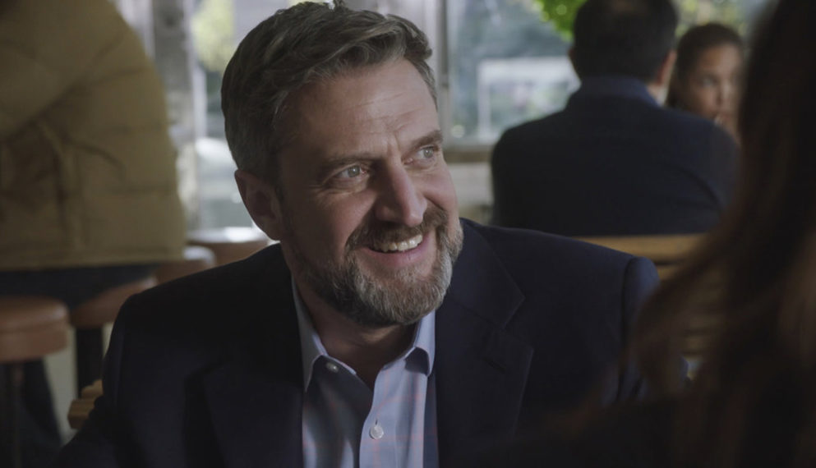

[**Raúl Esparza**](https://www.tvinsider.com/people/raul-esparza/) is back on [***Law & Order: SVU***](https://www.tvinsider.com/show/law-order-special-victims-unit/) in the January 7 episode, but there’s something different about his character, ruthless former assistant district attorney Rafael Barba.

Although he briefly video-chatted from Iowa with SVU captain Olivia Benson ([**Mariska Hargitay**](https://www.tvinsider.com/people/mariska-hargitay/)) in a February episode, when we last saw Barba *in* New York City, he had “left the DA’s office under a cloud,” showrunner Warren Leight tells TV Insider. (Barba had taken a comatose infant off life support.) “He comes back seeking if not revenge, at least closure.”

In “Sightless in a Savage Land,” the SVU squad tracks down an Amber Alert on New Year’s Eve, then Barba and ADA Sonny Carisi ([**Peter Scanavino**](https://www.tvinsider.com/people/peter-scanavino/)) face off in court. Now serving as defense counsel, Barba “has something to prove,” Leight says.

Producers looked at those scenes, with the former detective (Carisi) and the man who mentored him (Barba), “as rounds of a boxing match. One fighter more or less trained the other; now they are in the ring, neither wanting to give an inch,” the showrunner previews. “Director [and EP] Norberto Barba brought a pugilistic approach to each round. Emotionally, I think it’s obviously more loaded for Carisi than Barba—it’s never easy to go up against your mentor.”

Leight isn’t ruling out the possibility of seeing Esparza again soon. “I have learned, repeatedly, it’s futile to predict the future this season. Or even to predict the next hour,” he says, teasing, “We hope to bring Barba back, and we even have an episode worthy of the intelligence and theatricality he brings to the role of a defense attorney. With luck we’ll shoot it before season end.”

### [**‘SVU’ Table Read Teases Christopher Meloni’s Reunion With Mariska Hargitay (PHOTO)**](https://www.tvinsider.com/974764/law-order-svu-chris-meloni-stabler-benson-reunion-table-read/)

Meloni’s spinoff ‘Organized Crime’ will premiere in 2021.

For now, let’s just get ready to see Barba and Carisi go head-to-head in the courtroom.

***Law & Order: Special Victims Unit*, Thursdays, 9/8c, NBC**